

COURSE: | DATABASE SYSTEMS
LAB: | # 13
NAME: | MUZAMMIL BIN SOHAIL
ROLL NO.: | 22F - 3110
DEGREE: | BS - AI
SECTION: | 4A1

1)
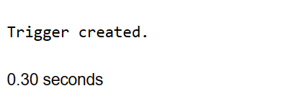
CREATE OR REPLACE TRIGGER before_employee_insert
BEFORE INSERT ON EMP
FOR EACH ROW
BEGIN
DBMS_OUTPUT.PUT_LINE('Inserting a new employee record');
END;
2)
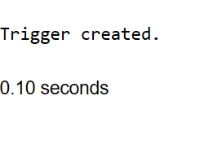
CREATE OR REPLACE TRIGGER salary_check
AFTER UPDATE ON EMP
FOR EACH ROW
BEGIN
IF :NEW.SAL > 10000 THEN
DBMS_OUTPUT.PUT_LINE('High salary!');
END IF;
END;
3)
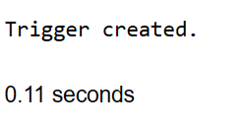
CREATE OR REPLACE TRIGGER prevent_manager_update
BEFORE UPDATE ON EMP
FOR EACH ROW
BEGIN
IF :NEW.JOB = 'MANAGER' THEN
RAISE_APPLICATION_ERROR(-20001, 'Cannot change the job title of a manager');
END IF;
END;
4)
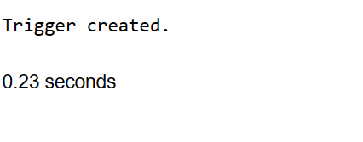
CREATE OR REPLACE TRIGGER employee_audit
AFTER INSERT OR UPDATE OR DELETE ON EMP
FOR EACH ROW
BEGIN
IF INSERTING THEN
INSERT INTO AUDIT_TABLE (ACTION, EMP_ID, TIMESTAMP)
VALUES ('INSERT', :NEW.EMPNO, SYSDATE);
ELSIF UPDATING THEN
INSERT INTO AUDIT_TABLE (ACTION, EMP_ID, TIMESTAMP)
VALUES ('UPDATE', :NEW.EMPNO, SYSDATE);
ELSIF DELETING THEN
INSERT INTO AUDIT_TABLE (ACTION, EMP_ID, TIMESTAMP)
VALUES ('DELETE', :OLD.EMPNO, SYSDATE);
END IF;
END;

create table audit_table(
action varchar(30),
emp_id int,
timestamp date)
5)
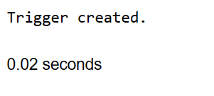
CREATE OR REPLACE TRIGGER enforce_department_limit
BEFORE INSERT ON EMP
FOR EACH ROW
DECLARE
emp_count NUMBER;
BEGIN
SELECT COUNT(*) INTO emp_count FROM EMP WHERE DEPTNO = :NEW.DEPTNO;
IF emp_count >= 10 THEN
RAISE_APPLICATION_ERROR(-20002, 'Department limit exceeded');
END IF;
END;
6)
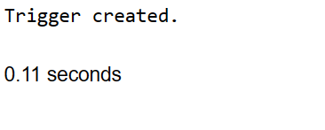
CREATE SEQUENCE EMP_SEQ
START WITH 1
INCREMENT BY 1;

CREATE OR REPLACE TRIGGER auto_increment_empno
BEFORE INSERT ON EMP
FOR EACH ROW
BEGIN
SELECT EMP_SEQ.NEXTVAL INTO :NEW.EMPNO FROM DUAL;
END;
7)
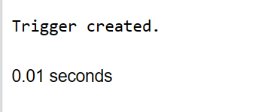
CREATE OR REPLACE TRIGGER prevent_salesman_deletion
BEFORE DELETE ON EMP
FOR EACH ROW
BEGIN
IF :OLD.JOB = 'SALESMAN' THEN
RAISE_APPLICATION_ERROR(-20003, 'Cannot delete a salesman');
END IF;
END;

